

|  |
| --- |
| 253-555-1111 |
| Smart Phone |
| Dyates7@wgu.edu |
| Envelope |
| Damian J. Yates |
| User |

http://www.damianjyates.com

Valued Staff

2325 SomeStreet, Somecity, WA 98372

Dear **Valued Staff**,

This week, IT will be deploying the software for our new phone system to every workstation in the company. There will be no configuration needed on the user’s side, installation is automated leaving you only with the difficult task of logging in when prompted. Users will see 3 new icons on their desktops like below:   
  
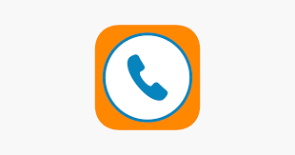  
  
**The first is for the soft phone - a program that lets you make and receive calls, faxes, and instant messages.  
  
The second is for the Collaboration app – everything in one place app that allows for chatting, team meetings, screen sharing and may other activities. For a complete list of features visit** [**https://glip.com/product**](https://glip.com/product)**.   
  
The third icon is the Meetings app – Allows every user to host or join a collaborative meeting with other users with or without the app. We will be conducting our all staff meetings here also to allow remote users the opportunity to participate.**For those individuals that have a need for a physical phone device do not worry, we thought about you as well. Just send a message to [helpdesk@damianjyates.com](mailto:helpdesk@damianjyates.com) and our support staff will work with you to get the device installed at your workstation. You will still have access to all the above-mentioned apps at your desktop as well.   
  
  
  
  
  
  
  
Most important are the training sessions that will be provided during the first week of October. The folks at Ring Central will be coming out to our site to provide 3 sessions for users and 2 sessions for administrative and technical staff. Please head out to <http://damianjyates.com/ringtraining> and sign up for a session. If you are not able to make any of the sessions, don’t worry, we have a plan for that as well. In addition to the superb documentation located at <https://support.ringcentral.com/s/?language=en_US>, they also have chat support to answer any question you may have.

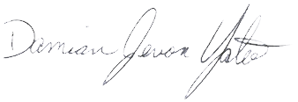We know that change can be a pain sometimes and because of this simple fact we want to hear about your experiences during this transition to the new phone system. We have a survey for any employee to fill out @ <http://www.damianjyates.com/ringsurvey>. With the responses received, we will as always, work to improve upon the processes that we have in place to make our work place a happier and more productive environment.

Warm regards,

Damian J. Yates

Owner